RECIPE
Author: Regina Dillard

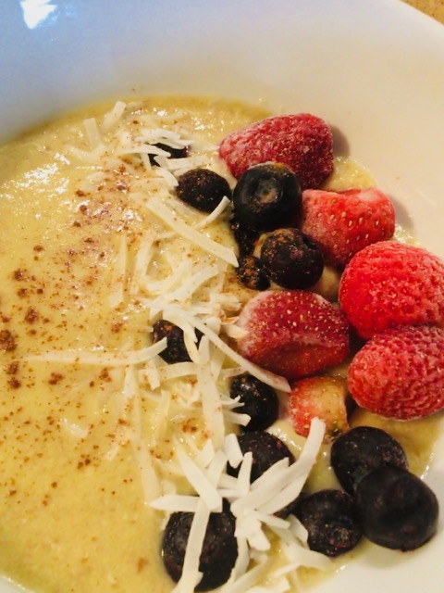
​

Ingredients
2 tablespoons coconut flour
2 tablespoons golden flax meal
1/2 tsp Cinnamon
1/2 tsp Pure Vanilla Extract
3/4 cup water
pinch of salt
1 large egg beaten
2 teaspoons coconut oil or ghee
1 tablespoon coconut cream
1 tablespoon of pure maple syrup or your favorite sweetener
Instructions
Measure the first five ingredients into a small pot over medium heat and stir. When it begins to simmer, turn it down to medium-low and whisk until it begins to thicken.
Remove the coconut flour porridge from heat and add the beaten egg, a small amount at a time, while whisking vigorously (otherwise eggs will scramble). Place back on the heat and continue to whisk until the porridge thickens.
Remove from the heat and continue to whisk for about 30 seconds before adding the coconut oil, coconut cream, salt and sweetener.
Garnish with your berries, sliced apples, or your favorite toppings

